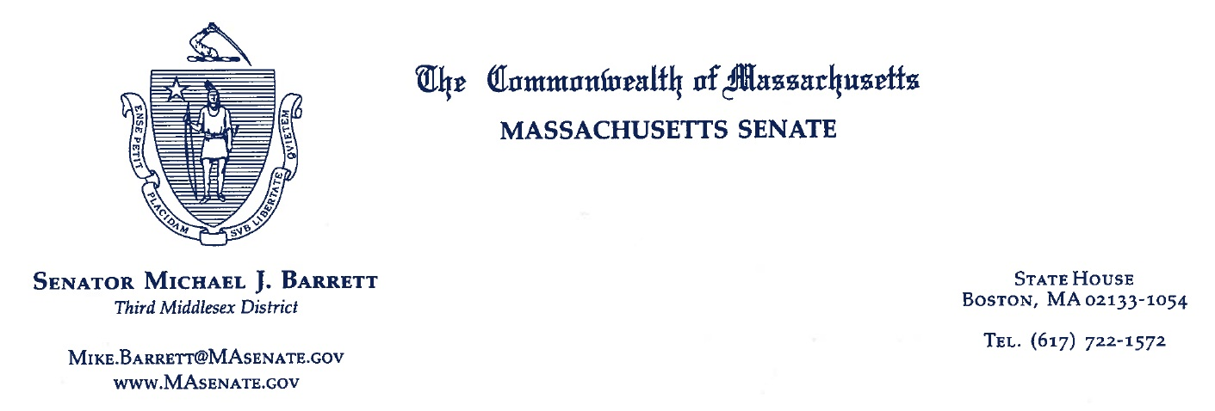

For Immediate Release: December 13, 2016
For further information, contact:
Brendan Berger, 617-722-1572;
Brendan.Berger@masenate.gov

Beacon Hill proposal targets tax returns of presidential candidates

BOSTON -- State Senator Mike Barrett (D-Lexington) wants the Massachusetts Legislature to tell future presidential candidates that they cannot appear on a primary or general election ballot in the state until they release their tax returns and disclose potential conflicts of interests.

“Until recently,” Barrett wrote in a Dear Colleague letter to House and Senate members inviting cosponsors of the bill in the upcoming 2017-2018 session, “many Americans just assumed that the stature of the Office of the President ensured the observance of certain practices that are unwritten but responsible and well-established, one of which is the disclosure by candidates of recent tax returns and, by extension, possible conflicts of interest. The 2016 election shattered this confidence. I hope we can come together to rebuild it.”

Going back at least 36 years, Barrett says, every major party candidate for President of the United States has released his or her tax returns, a tradition that ended with Donald Trump. Barrett contends that access to the Massachusetts primary and general election ballot is a matter within the purview of the state legislature. “So let’s set reasonable conditions that serve the public interest,” he says.

The legislation would require candidates in major party primary elections for president to submit their three most recently-filed tax returns to the Secretary of State, who would be obligated in turn to make the documents public at least 30 days before voting in the relevant primary begins.

The legislation also requires candidates for president and vice president in the November general election to submit their five most recently-filed tax returns to the Secretary of State, who would make the documents public at least 50 days before voting begins.

A third aspect of Barrett’s bill requires both primary and general election candidates to file Statements of Financial Interests like the ones required of candidates for Massachusetts state elected office, one that discloses businesses owned, real estate investments, financial investments, gifts and honoraria received, and financial debts and mortgage debts owed.

A candidate for president -- or vice president -- who did not comply with the three provisions would be ineligible to appear on the relevant Massachusetts ballot. To ensure compliance, a fourth provision of the Barrett bill would bar Massachusetts state electors from casting votes in the Electoral College for candidates who fail to meet the other three requirements.

Barrett wrote his colleagues, “Apologists for non-transparency will worry out loud that candidates may avoid competing in the state’s party primaries in order to duck disclosure and keep their financial entanglements hidden. But I doubt Massachusetts will be the only state to come forward in defense of the tradition of transparency. I was inspired to draft this bill by Brad Hoylman, a New York State Senator, who is proposing similar legislation for his state.”

The draft bill includes a severability clause. If any portion of the legislation were to be declared unconstitutional, the rest of the statute would remain in effect.

###

